**Zucchini Lasagna**

[[site-icon](http://www.skinnytaste.com/2009/02/zucchini-lasagna.html)**skinnytaste.com**/2009/02/zucchini-lasagna.html](http://www.skinnytaste.com/2009/02/zucchini-lasagna.html)

[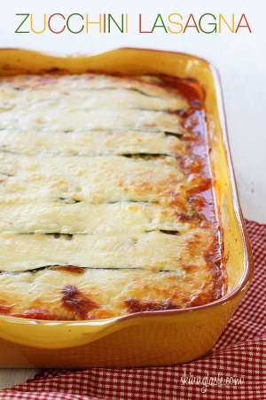](http://4.bp.blogspot.com/-H52YzJm1zmI/UFn92kI7ZgI/AAAAAAAAH8A/X8U6EL34dNY/s1600/Skinnytaste-Zucchini-Lasagna.jpg)  
By replacing the lasagna noodles with thin sliced zucchini you can create a delicious, lower carb (gluten-free) lasagna that's loaded with vegetables, and you won't miss the pasta!  
  
This recipe is from the archives, but needed a photo-makeover. I also like to make some of my older recipes over to see if I can improve them. I made slight adjustments to the original recipe, so if you have an old printout, you may want to re-print it. This feeds eight, and is quite filling. Everyone in my house likes it, including my picky daughter.  
  
The first time I made this, I didn't grill the zucchini first, but there was a lot of liquid so I found grilling it first greatly improved it. I soaked up as much of the liquid as I could with paper towels before layering the ingredients. I think the next time I make this, I'll try it with turkey sausage in place of the ground beef, I bet it will be spectacular!  
  
Tip: Using a [mandoline](http://www.amazon.com/OXO-Grips-V-Blade-Mandoline-Slicer/dp/B001THGPDO?ie=UTF8&tag=ginsweiwatrec-20&link_code=btl&camp=213689&creative=392969)http://www.assoc-amazon.com/e/ir?t=ginsweiwatrec-20&l=btl&camp=213689&creative=392969&o=1&a=B001THGPDO is a must to slice the zucchini thin, and it's quick and easy. You can also make the sauce ahead of time if you want to speed this up for a weeknight.

Zucchini Lasagna  
*Skinnytaste.com*   
**Servings:** 8 **• Serving Size:** 1/8 **• Old Points:** 8 pts **• Points+:** 9 pts  
**Calories:** 345 **• Fat:** 17 g **• Carbs:** 16 g **• Fiber:** 2 g **• Protein:** 36 g **• Sugar:** 8 g  
**Sodium:** 801 (without salt)   
  
Ingredients:

* [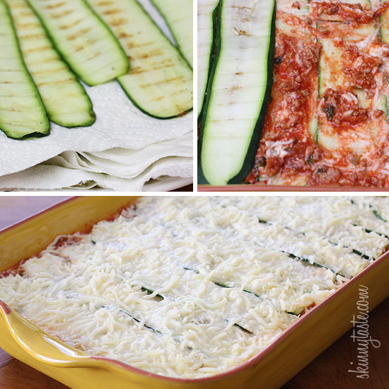](http://4.bp.blogspot.com/-BRAZHKkjARc/UFn925ELNMI/AAAAAAAAH8I/4lr8sYtuSxI/s1600/Steps-Zucchini-Lasagna.jpg)1 lb 93% lean beef
* 3 cloves garlic
* 1/2 onion
* 1 tsp olive oil
* salt and pepper
* 28 oz can crushed tomatoes
* 2 tbsp chopped fresh basil
* 3 medium zucchini, sliced 1/8" thick
* 15 oz part-skim ricotta
* 16 oz part-skin mozzarella cheese, shredded (Sargento)
* 1/4 cup Parmigiano Reggiano
* 1 large egg

Directions:

In a medium sauce pan, brown meat and season with salt. When cooked drain in colander to remove any fat. Add olive oil to the pan and saute garlic and onions about 2 minutes. Return the meat to the pan, add tomatoes, basil, salt and pepper. Simmer on low for at least 30-40minutes, covered. Do not add extra water, the sauce should be thick.  
  
[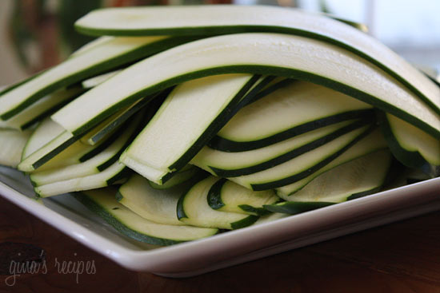](http://picasaweb.google.com/lh/photo/Yqhn2niJL2iCtJW6kTnxkA?authkey=4geqgcciFxA&feat=embedwebsite)  
  
Meanwhile, slice zucchini into 1/8" thick slices, add lightly salt and set aside or 10 minutes. Zucchini has a lot of water when cooked, salting it takes out a lot of moisture. After 10 minutes, blot excess moisture with a paper towel.  
  
On a gas grill or grill pan, **grill** zucchini on each side, until cooked, about 1-2 minutes per side. Place on paper towels to soak any excess moisture.  
  
Preheat oven to 350°.  
  
In a medium bowl mix ricotta cheese, parmesan cheese and egg. Stir well.   
  
  
In a 9x12 casserole spread some sauce on the bottom and layer the zucchini to cover. Then place some of the ricotta cheese mixture, then top with the mozzarella cheese and repeat the process until all your ingredients are used up. Top with sauce and mozzarella and cover with foil.

Bake 45 minutes covered at 375°, then uncovered 15 minutes. Let stand about 5 - 10 minutes before serving.